AWS SNS SERVICE:-

1. SIMPLE NOTIFICATION SERVICE CAN USE TO RECEIVES NOTIFICATION FROM AWS.
2. WE CONFIGURE THIS SNS SERVICE INTO ANY SERVICES IN AWS,FOR EXAMPLE S3 BUCKET.
3. IF ANY ONE UPLOADED OR DELTED FILE INTO MY S3 BUCKET THEN I WILL RECIVES MAIL OR SMS FROM THAT. FOR THAT I AM CONFIGURING AWS SNS SERVICE INTO S3 BUCKET.
4. BELOW ARE THE STEPS TO CONFIGURE AWS SNS SERVICE.

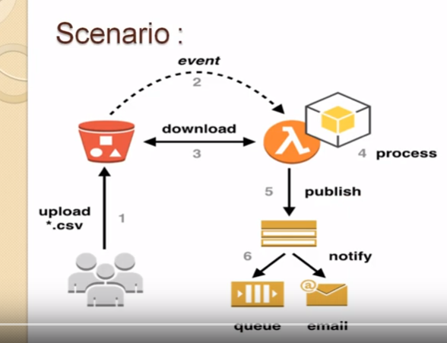

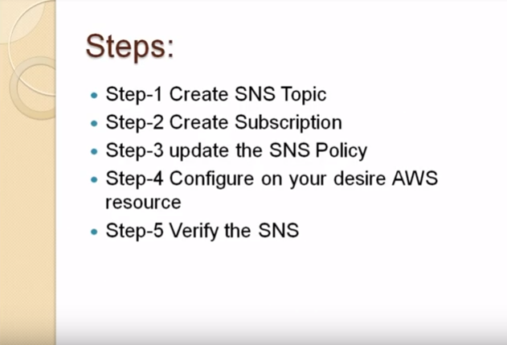

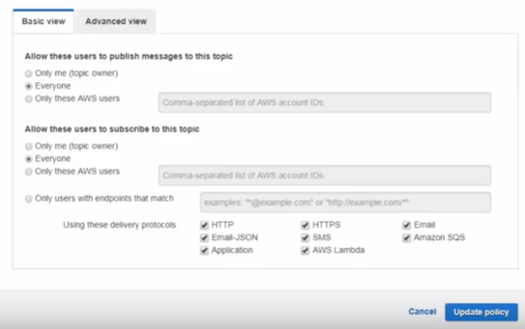

(OR)

Access policy-options (JSON configuration):-

{ "Version": "2008-10-17",

"Id": "__default_policy_ID",

"Statement": [ { "Sid": "publish-from-s3",

"Effect": "Allow",

"Principal": { "Service": "s3.amazonaws.com" },

"Action": "SNS:Publish",

"Resource": "arn:aws:sns:ap-south-1:343490998241:messagetest",

"Condition": { "ArnLike": { "aws:SourceArn": "arn:aws:s3:*:*:kesavatestsns" }}}]}

Note:-

For more reference follow this video :- <https://www.youtube.com/watch?v=DEq-uWVGEDk>